# **Section 4 Assignment (123 points) – Boolean Functions**

To receive credit, you must either show your work on the worksheet or explain how you got the answer.

80/123

1. (12 points) Indicate whether the following Boolean expressions are in conjunctive normal form (CNF), disjunctive normal form (DNF), both (B), or neither (N).
   1. (4 pts) CNF / DNF / B / N

CNF

* 1. (4 pts) CNF / DNF / B / N $xz+\overline{y}$

B Here I think I just wrote down the wrong answer on accident

* 1. (4 pts) CNF / DNF / B / N $\left(\overset{´}{x}+3\right)$

B

1. (10 points) Using the *Simplification Rules for Boolean Variables* and the *Laws of Boolean Algebra,* determine if the two Boolean expressions in each pair are equivalent:

$\overline{x+\overline{y}}+\overline{x}\overline{y}=\overline{y}$

~x+y+~x~y

~x+y

no they are not equivilant

1. (20 points) Give the Boolean function described by the following digital logic (circuit) diagrams
   1. (4 pts)



~(~x + ~y)

xy

* 1. (6 pts)





(x+y)+~(x(x+y)) here I used ~ instead of ‘ but it is the same answer

(x+y)+~(xx+xy)

(x+y)+~(x+xy)

x+y+~x

x+~x

true

* 1. (10 pts)





 ~((xy)+((x+y)(x+(yz)))) here I used ~ instead of ‘ but it is the same answer





1. (15 pts) For question 3c, use the laws of Boolean algebra to find a simpler circuit that computes the same function (you don’t need to draw it). How many gates would it use?

~((xy)+((x+y)(x+(yz))))

(~x~y)+~((x+y)(x+y)(x+z))

(~x~y)+~((x+y)(x+z))

(~x~y)+~(x+y)~(x+z)

(~x~y)+(~x~z)

it would require 7 gates

4 not

2 and

1 or

I guess I just didnt simplify it all the way or I didnt simplify it the right way. it does the same job though



1. (18 points) Draw the digital logic (circuit) diagrams for the following Boolean functions
   1. (6 pts) $\left(xy\right)\left(y+\overset{´}{z}\right)$

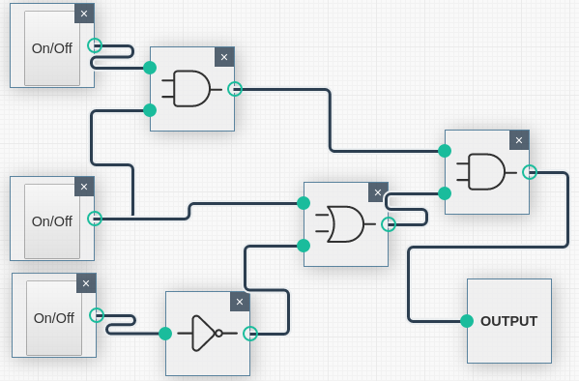

from top to bottom the inputs are:

x

y

z

* 1. (6 pts)

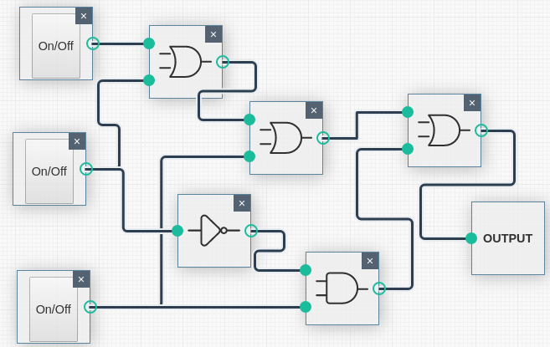

from top to bottom the inputs are:

x

y

z

* 1. (6 pts)

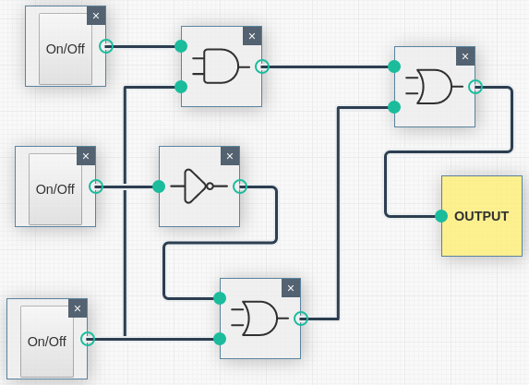

from top to bottom the inputs are:

x

y

z

I didnt realize that the bar above the y and z didnt appear correctly in the document: it showed up to me as xz+y’+z and not xz+(y+z)’ as it does in the pdf.

1. (18 points) For each Karnaugh map, use the *Kmap Grouping Rules* to group the elements and then list the simplified Boolean expression:
   1. (4 pts)

~x~y+xy



|  |  |  |
| --- | --- | --- |
|  | *y`* | *y* |
| x` | 1 |  |
| x |  | 1 |

* 1. (6 pts)

|  |  |  |  |  |
| --- | --- | --- | --- | --- |
|  | *y`* | *y`* | *y* | *y* |
| x` |  |  |  |  |
| x | 1 | 1 | 1 | 1 |
|  | z` | z | z | z` |

x

* 1. (8 pts)

|  |  |  |  |  |  |
| --- | --- | --- | --- | --- | --- |
|  | *z`* | *z`* | *z* | *z* |  |
| x` | 1 | 1 | 1 | 1 | y` |
| x` | 1 | 1 | 1 | 1 | y |
| x |  |  |  | 1 | y |
| x | 1 |  |  | 1 | y` |
|  | w` | w | w | w` |  |

~x+~wz+~w~z~y

I didnt simplify it

1. (30 points) For each truth table, fill in the k-map, use the *Kmap Grouping Rules* to group the elements, and then list the simplified Boolean expression:

|  |  |  |
| --- | --- | --- |
| ***x*** | ***y*** | ***f(x,y)*** |
| 1 | 1 | 0 |
| 1 | 0 | 1 |
| 0 | 1 | 0 |
| 0 | 0 | 1 |

a. (4 pts)

|  |  |  |
| --- | --- | --- |
|  | *y* | *y`* |
| x |  | 1 |
| x` |  | 1 |

**~y**

b. (4 pts)

|  |  |  |
| --- | --- | --- |
| ***x*** | ***y*** | ***f(x,y)*** |
| 1 | 1 | 1 |
| 1 | 0 | 0 |
| 0 | 1 | 1 |
| 0 | 0 | 1 |

|  |  |  |
| --- | --- | --- |
|  | *y* | *y`* |
| x | 1 |  |
| x` | 1 | 1 |

**y+~x**



|  |  |  |  |
| --- | --- | --- | --- |
| ***x*** | ***y*** | ***z*** | ***f(x,y,z)*** |
| 1 | 1 | 1 | 1 |
| 1 | 1 | 0 | 1 |
| 1 | 0 | 1 | 0 |
| 1 | 0 | 0 | 1 |
| 0 | 1 | 1 | 1 |
| 0 | 1 | 0 | 1 |
| 0 | 0 | 1 | 0 |
| 0 | 0 | 0 | 1 |

|  |  |  |
| --- | --- | --- |
|  | *z* | *z`* |
| xy | 1 | 1 |
| x`y | 1 | 1 |
| x`y` |  | 1 |
| xy` |  | 1 |

c. (6 pts) y+~z

d. (6 pts)

|  |  |  |  |
| --- | --- | --- | --- |
| ***x*** | ***y*** | ***z*** | ***f(x,y,z)*** |
| 1 | 1 | 1 | 1 |
| 1 | 1 | 0 | 1 |
| 1 | 0 | 1 | 1 |
| 1 | 0 | 0 | 1 |
| 0 | 1 | 1 | 0 |
| 0 | 1 | 0 | 0 |
| 0 | 0 | 1 | 0 |
| 0 | 0 | 0 | 0 |

|  |  |  |
| --- | --- | --- |
|  | *z* | *z`* |
| xy | 1 |  |
| x`y | 1 |  |
| x`y` | 1 |  |
| xy` | 1 |  |

x

e. (10 pts) zw(x+~y)+~xy(~z~w)+z~w(xy) Not simplified

|  |  |  |  |  |
| --- | --- | --- | --- | --- |
|  | *zw* | *z`w* | *z`w`* | *zw`* |
| xy | 1 | 0 | 0 | 1 |
| x`y | 0 | 1 | 1 | 1 |
| x`y` | 1 | 0 | 0 | 0 |
| xy` | 1 | 0 | 0 | 1 |

|  |  |  |  |  |
| --- | --- | --- | --- | --- |
| ***x*** | ***y*** | ***z*** | ***w*** | ***f(x,y,z,w)*** |
| 1 | 1 | 1 | 1 | 1 |
| 1 | 1 | 1 | 0 | 1 |
| 1 | 1 | 0 | 1 | 0 |
| 1 | 1 | 0 | 0 | 0 |
| 1 | 0 | 1 | 1 | 1 |
| 1 | 0 | 1 | 0 | 1 |
| 1 | 0 | 0 | 1 | 0 |
| 1 | 0 | 0 | 0 | 0 |
| 0 | 1 | 1 | 1 | 0 |
| 0 | 1 | 1 | 0 | 1 |
| 0 | 1 | 0 | 1 | 1 |
| 0 | 1 | 0 | 0 | 1 |
| 0 | 0 | 1 | 1 | 0 |
| 0 | 0 | 1 | 0 | 1 |
| 0 | 0 | 0 | 1 | 0 |
| 0 | 0 | 0 | 0 | 0 |

